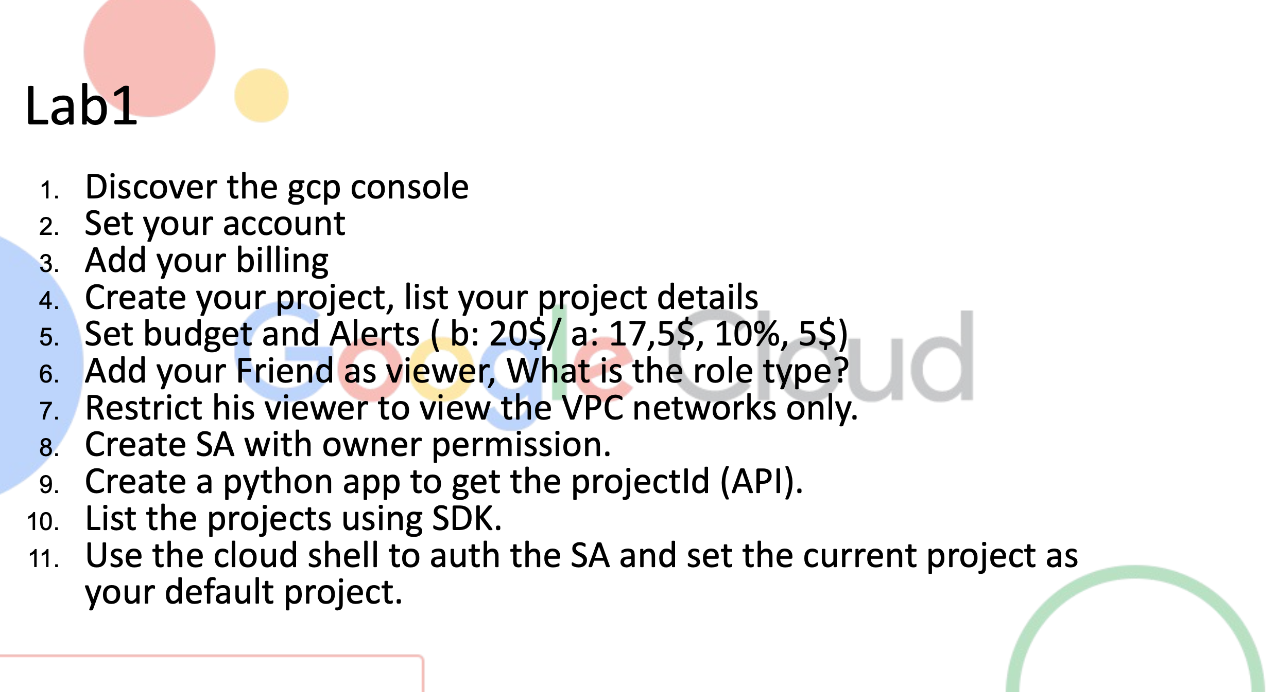
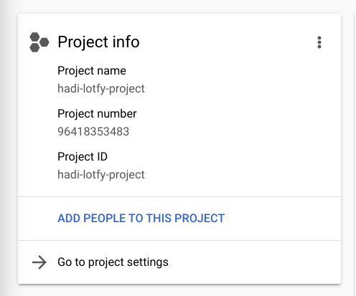
- Discover the gcp console.
- Set your account
Name: Hadi Lotfy
Host: Andrew Anter
Project Name: hadi-lotfy-project
Project Number: 96418353483
Project ID: hadi-lotfy-project

- Add your billing
- Create your project,list your project details.
- Set budget and Alerts
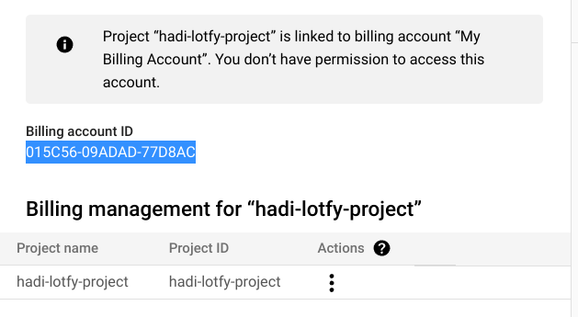

- Add your Friend as viewer, What is the role type? >>>> Basic Role
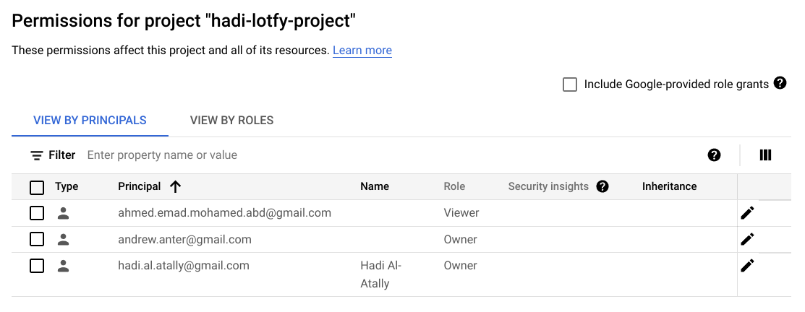
- Restrict his viewer role to view the VPC network only.
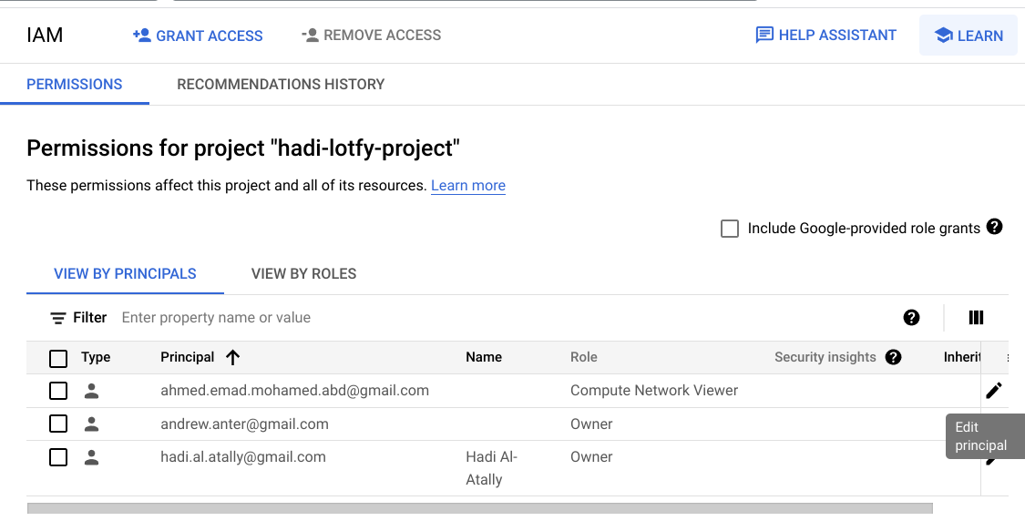
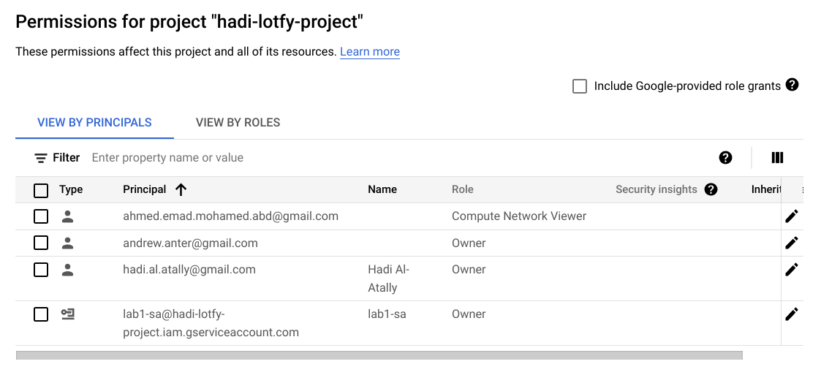
- Create SA with owner permission
- Create a python app to get the project id (API)
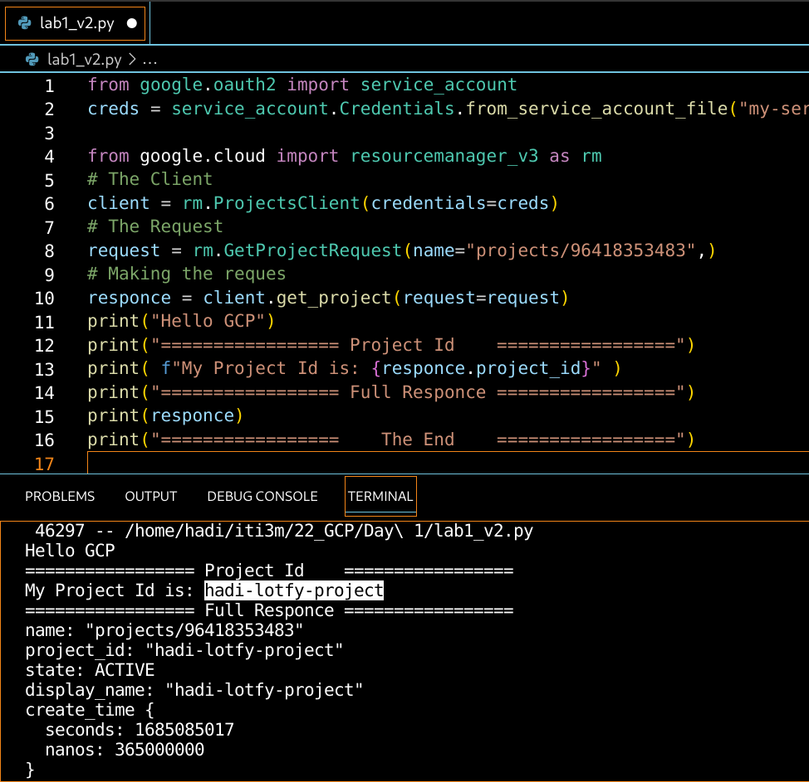
- List the Projects using SDK
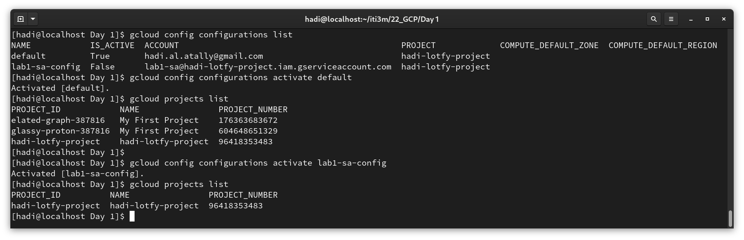
- Use the cloud shell to auth the SA and set the current project as your default project.
